**Day 36-MongoDB Task**

**Design database for Zen class programme**

**1.Users**

{

  _id: ObjectId('663b256a40a3f72bd676356c'),

  user_id: 1,

  name: 'Raja',

  email: 'raja001@gmail.com',

  userContactDetails: '6383574221',

  userBatchId: '1',

  feesPaid: true,

  placementEnabled: false,

  userPrimaryLanguage: 'Tamil',

  userSecondaryLanguage: 'English',

  isCourseRestarted: true,

  userROle: 'student'

}

{

  _id: ObjectId('663b256a40a3f72bd676356d'),

  user_id: 2,

  name: 'Rakesh',

  email: 'rakesh401@gmail.com',

  userContactDetails: '6383574331',

  userBatchId: '2',

  feesPaid: true,

  placementEnabled: true,

  userPrimaryLanguage: 'Tamil',

  userSecondaryLanguage: 'English',

  isCourseRestarted: true,

  userROle: 'student'

}

{

  "_id": {

"$oid": "663b256a40a3f72bd676356e"

  },

  "user_id": 3,

  "name": "Deepak",

  "email": "deepakcovai007@gmail.com",

  "userContactDetails": "6384474221",

  "userBatchId": "1",

  "feesPaid": true,

  "placementEnabled": true,

  "userPrimaryLanguage": "Tamil",

  "userSecondaryLanguage": "Hindi",

  "isCourseRestarted": true,

  "userROle": "student"

}

{

  "_id": {

"$oid": "663b256a40a3f72bd676356f"

  },

  "user_id": 4,

  "name": "Ranger",

  "email": "rangerkutty@gmail.com",

  "userContactDetails": "9583574221",

  "userBatchId": "1",

  "feesPaid": true,

  "placementEnabled": true,

  "userPrimaryLanguage": "Tamil",

  "userSecondaryLanguage": "English",

  "isCourseRestarted": true,

  "userROle": "student"

}

{

  "_id": {

"$oid": "663b256a40a3f72bd6763570"

  },

  "user_id": 5,

  "name": "bhuvi",

  "email": "bhuvikan@gmail.com",

  "userContactDetails": "6384374221",

  "userBatchId": "1",

  "feesPaid": true,

  "placementEnabled": true,

  "userPrimaryLanguage": "Tamil",

  "userSecondaryLanguage": "English",

  "isCourseRestarted": true,

  "userROle": "student"

}

{

  "_id": {

"$oid": "663b256a40a3f72bd6763571"

  },

  "user_id": 6,

  "name": "Vadivel",

  "email": "vadivelarul@gmail.com",

  "userContactDetails": "6353574221",

  "userBatchId": "2",

  "feesPaid": true,

  "placementEnabled": true,

  "userPrimaryLanguage": "Tamil",

  "userSecondaryLanguage": "English",

  "isCourseRestarted": true,

  "userROle": "student"

}

{

  "_id": {

"$oid": "663b256a40a3f72bd6763572"

  },

  "user_id": 7,

  "name": "Pritham",

  "email": "pritham021@gmail.com",

  "userContactDetails": "9783574221",

  "userBatchId": "1",

  "feesPaid": true,

  "placementEnabled": true,

  "userPrimaryLanguage": "Tamil",

  "userSecondaryLanguage": "English",

  "isCourseRestarted": true,

  "userROle": "student"

}

{

  "_id": {

"$oid": "663b256a40a3f72bd6763573"

  },

  "user_id": 8,

  "name": "Milan",

  "email": "milanking@gmail.com",

  "userContactDetails": "6383574435",

  "userBatchId": "1",

  "feesPaid": true,

  "placementEnabled": true,

  "userPrimaryLanguage": "Tamil",

  "userSecondaryLanguage": "English",

  "isCourseRestarted": true,

  "userROle": "student"

}

{

  "_id": {

"$oid": "663b256a40a3f72bd6763574"

  },

  "user_id": 9,

  "name": "Roy",

  "email": "roythamos@gmail.com",

  "userContactDetails": "9724574435",

  "userBatchId": "2",

  "feesPaid": true,

  "placementEnabled": true,

  "userPrimaryLanguage": "Tamil",

  "userSecondaryLanguage": "English",

  "isCourseRestarted": true,

  "userROle": "student"

}

{

  "_id": {

"$oid": "663b256a40a3f72bd6763575"

  },

  "user_id": 10,

  "name": "virat kholi",

  "email": "viratrcb@gmail.com",

  "userContactDetails": "7383575435",

  "userBatchId": "1",

  "feesPaid": true,

  "placementEnabled": true,

  "userPrimaryLanguage": "Tamil",

  "userSecondaryLanguage": "English",

  "isCourseRestarted": true,

  "userROle": "student"

}

{

  "_id": {

"$oid": "663b256a40a3f72bd6763576"

  },

  "user_id": 11,

  "name": "Devesh",

  "email": "devesh@gmail.com",

  "userContactDetails": "7673575435",

  "userBatchId": "1",

  "feesPaid": true,

  "placementEnabled": true,

  "userPrimaryLanguage": "Tamil",

  "userSecondaryLanguage": "English",

  "isCourseRestarted": true,

  "userROle": "student"

}

{

  "_id": {

"$oid": "663b256a40a3f72bd6763577"

  },

  "user_id": 12,

  "name": "Divya",

  "email": "divyanaga@gmail.com",

  "userContactDetails": "7383575245",

  "userBatchId": "1",

  "feesPaid": true,

  "placementEnabled": true,

  "userPrimaryLanguage": "Tamil",

  "userSecondaryLanguage": "English",

  "isCourseRestarted": true,

  "userROle": "student"

}

{

  "_id": {

"$oid": "663b256a40a3f72bd6763578"

  },

  "user_id": 13,

  "name": "Rasmita",

  "email": "rastmitarani@gmail.com",

  "userContactDetails": "8959647746",

  "userBatchId": "1",

  "feesPaid": true,

  "placementEnabled": true,

  "userPrimaryLanguage": "Tamil",

  "userSecondaryLanguage": "English",

  "isCourseRestarted": true,

  "userROle": "student"

}

**2.codekata**

{

  _id: ObjectId('663b28f540a3f72bd676357b'),

  codekata_id: 1,

  user_id: 3,

  problems_solved: 13,

  updatedOn: 2024-05-08T00:00:00.000Z,

  date_completed: 2024-05-08T00:00:00.000Z

}

{

  _id: ObjectId('663b28f540a3f72bd676357a'),

  codekata_id: 1,

  user_id: 2,

  problems_solved: 6,

  updatedOn: 2024-05-08T00:00:00.000Z,

  date_completed: 2024-05-08T00:00:00.000Z

}

{

  _id: ObjectId('663b28f540a3f72bd676357b'),

  codekata_id: 1,

  user_id: 3,

  problems_solved: 13,

  updatedOn: 2024-05-08T00:00:00.000Z,

  date_completed: 2024-05-08T00:00:00.000Z

}

{

  _id: ObjectId('663b28f540a3f72bd676357c'),

  codekata_id: 1,

  user_id: 4,

  problems_solved: 20,

  updatedOn: 2024-05-08T00:00:00.000Z,

  date_completed: 2024-05-08T00:00:00.000Z

}

{

  _id: ObjectId('663b28f540a3f72bd676357d'),

  codekata_id: 1,

  user_id: 5,

  problems_solved: 14,

  updatedOn: 2024-05-08T00:00:00.000Z,

  date_completed: 2024-05-08T00:00:00.000Z

}

{

  _id: ObjectId('663b28f540a3f72bd676357e'),

  codekata_id: 1,

  user_id: 6,

  problems_solved: 15,

  updatedOn: 2024-05-08T00:00:00.000Z,

  date_completed: 2024-05-08T00:00:00.000Z

}

{

  _id: ObjectId('663b28f540a3f72bd676357f'),

  codekata_id: 1,

  user_id: 7,

  problems_solved: 13,

  updatedOn: 2024-05-08T00:00:00.000Z,

  date_completed: 2024-05-08T00:00:00.000Z

}

{

  _id: ObjectId('663b28f540a3f72bd6763580'),

  codekata_id: 1,

  user_id: 8,

  problems_solved: 16,

  updatedOn: 2024-05-08T00:00:00.000Z,

  date_completed: 2024-05-08T00:00:00.000Z

}

{

  _id: ObjectId('663b28f540a3f72bd6763581'),

  codekata_id: 1,

  user_id: 9,

  problems_solved: 15,

  updatedOn: 2024-05-08T00:00:00.000Z,

  date_completed: 2024-05-08T00:00:00.000Z

}

{

  _id: ObjectId('663b28f540a3f72bd6763582'),

  codekata_id: 1,

  user_id: 10,

  problems_solved: 18,

  updatedOn: 2024-05-08T00:00:00.000Z,

  date_completed: 2024-05-08T00:00:00.000Z

}

{

  _id: ObjectId('663b28f540a3f72bd6763583'),

  codekata_id: 1,

  user_id: 11,

  problems_solved: 15,

  updatedOn: 2024-05-08T00:00:00.000Z,

  date_completed: 2024-05-08T00:00:00.000Z

}

{

  _id: ObjectId('663b28f540a3f72bd6763584'),

  codekata_id: 1,

  user_id: 12,

  problems_solved: 15,

  updatedOn: 2024-05-08T00:00:00.000Z,

  date_completed: 2024-05-08T00:00:00.000Z

}

{

  _id: ObjectId('663b28f540a3f72bd6763585'),

  codekata_id: 1,

  user_id: 13,

  problems_solved: 19,

  updatedOn: 2024-05-08T00:00:00.000Z,

  date_completed: 2024-05-08T00:00:00.000Z

}

{

  _id: ObjectId('66a706fc84cea6ca0a560c53'),

  user_id: ObjectId('64b4cdeb1c4ae65870d1f1f1'),

  problems_solved: 50

}

{

  _id: ObjectId('66a706fc84cea6ca0a560c54'),

  user_id: ObjectId('64b4cdeb1c4ae65870d1f1f2'),

  problems_solved: 70

}

3.attendance

{

  _id: ObjectId('663c3003e882579def82b17b'),

  attendance_id: 1,

  userBatchId: 1,

  user_id: 1,

  taskId: 1,

  date: 2024-05-08T00:00:00.000Z,

  status: 'present'

}

{

  _id: ObjectId('663c3003e882579def82b17c'),

  attendance_id: 2,

  userBatchId: 2,

  user_id: 2,

  taskId: 1,

  date: 2024-05-08T00:00:00.000Z,

  status: 'present'

}

{

  _id: ObjectId('663c3003e882579def82b17d'),

  attendance_id: 3,

  userBatchId: 1,

  user_id: 3,

  taskId: 1,

  date: 2024-05-08T00:00:00.000Z,

  status: 'present'

}

{

  _id: ObjectId('663c3003e882579def82b17e'),

  attendance_id: 4,

  userBatchId: 1,

  user_id: 4,

  taskId: 1,

  date: 2024-05-08T00:00:00.000Z,

  status: 'present'

}

{

  _id: ObjectId('663c3003e882579def82b17f'),

  attendance_id: 5,

  userBatchId: 1,

  user_id: 5,

  taskId: 1,

  date: 2024-05-08T00:00:00.000Z,

  status: 'present'

}

{

  _id: ObjectId('663c3003e882579def82b180'),

  attendance_id: 6,

  userBatchId: 2,

  user_id: 6,

  taskId: 1,

  date: 2024-05-08T00:00:00.000Z,

  status: 'present'

}

{

  _id: ObjectId('663c3003e882579def82b181'),

  attendance_id: 7,

  userBatchId: 1,

  user_id: 7,

  taskId: 1,

  date: 2024-05-08T00:00:00.000Z,

  status: 'present'

}

{

  _id: ObjectId('663c3003e882579def82b182'),

  attendance_id: 8,

  userBatchId: 1,

  user_id: 8,

  taskId: 1,

  date: 2024-05-08T00:00:00.000Z,

  status: 'present'

}

{

  _id: ObjectId('663c3003e882579def82b183'),

  attendance_id: 9,

  userBatchId: 2,

  user_id: 9,

  taskId: 1,

  date: 2024-05-08T00:00:00.000Z,

  status: 'present'

}

{

  _id: ObjectId('663c3003e882579def82b184'),

  attendance_id: 10,

  userBatchId: 1,

  user_id: 10,

  taskId: 1,

  date: 2024-05-08T00:00:00.000Z,

  status: 'present'

}

{

  _id: ObjectId('663c3003e882579def82b185'),

  attendance_id: 11,

  userBatchId: 1,

  user_id: 11,

  taskId: 1,

  date: 2024-05-08T00:00:00.000Z,

  status: 'present'

}

{

  _id: ObjectId('663c3003e882579def82b186'),

  attendance_id: 12,

  userBatchId: 1,

  user_id: 12,

  taskId: 1,

  date: 2024-05-08T00:00:00.000Z,

  status: 'present'

}

{

  _id: ObjectId('663c3003e882579def82b187'),

  attendance_id: 13,

  userBatchId: 1,

  user_id: 13,

  taskId: 1,

  date: 2024-05-08T00:00:00.000Z,

  status: 'present'

}

{

  _id: ObjectId('66a706eb84cea6ca0a560c51'),

  user_id: ObjectId('64b4cdeb1c4ae65870d1f1f1'),

  date: 2020-10-16T00:00:00.000Z,

  status: 'present'

}

{

  _id: ObjectId('66a706eb84cea6ca0a560c52'),

  user_id: ObjectId('64b4cdeb1c4ae65870d1f1f2'),

  date: 2020-10-16T00:00:00.000Z,

  status: 'absent'

}

4.topics

{

  _id: ObjectId('6644a1e5f699bdebea8a1b92'),

  topic_id: 1,

  topic_name: 'MongoDB Basics',

  topicContent: 'MongoDB is a popular NoSQL database that is designed to store and manage large volumes of data. MongoDB is a document-oriented database that stores data in JSON-like documents. MongoDB is designed to be highly scalable and flexible, making it a popular choice for applications that require high performance and scalability. MongoDB',

  topicDate: '2023-02-01',

  topicTaskId: 1

}

{

  _id: ObjectId('66a7068984cea6ca0a560c4b'),

  topic_name: 'JavaScript',

  date: 2020-10-05T00:00:00.000Z

}

{

  _id: ObjectId('66a7068984cea6ca0a560c4b'),

  topic_name: 'JavaScript',

  date: 2020-10-05T00:00:00.000Z

}

5.tasks

_id: ObjectId('6644a2acf699bdebea8a1b93'),

  task_id: 1,

  topic_id: 1,

  task_name: 'Create MongoDB Schema',

  date_assigned: 2024-05-08T00:00:00.000Z,

  date_due: 2024-05-15T00:00:00.000Z,

  status: 'not submitted'

{

  _id: ObjectId('66a7069a84cea6ca0a560c4d'),

  topic_id: ObjectId('64b4cf231c4ae65870d1f1f3'),

  task_name: 'JavaScript Task',

  submission_date: 2020-10-06T00:00:00.000Z

}

{

  _id: ObjectId('66a7069a84cea6ca0a560c4d'),

  topic_id: ObjectId('64b4cf231c4ae65870d1f1f3'),

  task_name: 'JavaScript Task',

  submission_date: 2020-10-06T00:00:00.000Z

}

6.company_drives

{

  _id: ObjectId('663c3769e882579def82b188'),

  drive_id: 1,

  company_name: 'Accel Frontline Ltd',

  companyDetails: 'Accel Frontline Limited an Indian company based in Chennai, India. It is a subsidiary expansion of CAC holdings corporation which is based out of Tokyo, Japan. Founded in 1991, it deals with some of the most growing innovation in Software industries like cloud computing, IoT, product engineering services, etc. It has its presence in more than 100 locations in India and has a global presence across major countries around the globe.',

  companyWebsite: 'https://www.accel.com/india-home',

  skillsNeeded: [

'java',

'C',

'C++'

  ],

  date: 2020-10-15T00:00:00.000Z,

  driveMode: 'online'

}

{

  _id: ObjectId('663c3769e882579def82b189'),

  drive_id: 2,

  company_name: 'Accenture',

  companyDetails: 'Accenture is one of the pioneers in terms of multi-professional IT services like strategy, innovation, and digital aspects. It was founded in 1989 and is headquartered in Dublin Ireland. Accenture is one of the best IT Companies in Chennai. It is handled by David Rowland (CEO) and has multiple office locations in India including Chennai.',

  companyWebsite: 'https://accenture.com/in-en/about/company',

  skillsNeeded: [

'java',

'javascript',

'htlm',

'css',

'C',

'C++'

  ],

  date: 2020-10-14T00:00:00.000Z,

  driveMode: 'online'

}

{

  _id: ObjectId('663c3769e882579def82b18a'),

  drive_id: 3,

  company_name: 'Capgemini',

  companyDetails: 'Another giant in Software Industry, Capgemini is a French company headquartered in Paris. It has more than 200,00 employees and has its existence in more than 40 countries. It is headed by CEO Mr. Paul Herman. They are basically into IT solutions like consulting, technological aspects, outsourcing, and professional services.',

  companyWebsite: 'https://www.capgemini.com/',

  skillsNeeded: [

'java',

'C',

'C++',

'python'

  ],

  date: 2020-10-31T23:59:59.000Z,

  driveMode: 'online'

}

{

  _id: ObjectId('66a706a884cea6ca0a560c4f'),

  company_name: 'Google',

  date: 2020-10-20T00:00:00.000Z,

  students_appeared: [

    ObjectId('64b4cdeb1c4ae65870d1f1f1')

  ]

}

{

  _id: ObjectId('66a706a884cea6ca0a560c50'),

  company_name: 'Amazon',

  date: 2020-10-25T00:00:00.000Z,

  students_appeared: [

    ObjectId('64b4cdeb1c4ae65870d1f1f2')

  ]

}

7.mentors

db.mentors.insertMany([

  {

_id: ObjectId("6644a42af699bdebea8a1b94"),

mentor_id: 1,

name: 'Vishnu varadhhan',

mentees: []

  },

  {

_id: ObjectId("6644a42af699bdebea8a1b95"),

mentor_id: 2,

name: 'Kanmani',

mentees: []

  },

  {

_id: ObjectId("66a7768d84cea6ca0a560c55"),

mentor_id: 3,

name: 'Mentor1',

mentees: [

   ObjectId("64b4cdeb1c4ae65870d1f1f1"),

      ObjectId("64b4cdeb1c4ae65870d1f1f2"),

      ObjectId("64b4cdeb1c4ae65870d1f1f3"),

      ObjectId("64b4cdeb1c4ae65870d1f1f4"),

      ObjectId("64b4cdeb1c4ae65870d1f1f5"),

      ObjectId("64b4cdeb1c4ae65870d1f1f6"),

      ObjectId("64b4cdeb1c4ae65870d1f1f7"),

      ObjectId("64b4cdeb1c4ae65870d1f1f8"),

      ObjectId("64b4cdeb1c4ae65870d1f1f9"),

      ObjectId("64b4cdeb1c4ae65870d1f1fa"),

      ObjectId("64b4cdeb1c4ae65870d1f1fb"),

      ObjectId("64b4cdeb1c4ae65870d1f1fc"),

      ObjectId("64b4cdeb1c4ae65870d1f1fd"),

      ObjectId("64b4cdeb1c4ae65870d1f1fe"),

      ObjectId("64b4cdeb1c4ae65870d1f1ff"),

      ObjectId("64b4cdeb1c4ae65870d1f1f0")

]

  }

]);

Queries:

1. Find all the topics and tasks which are thought in the month of October

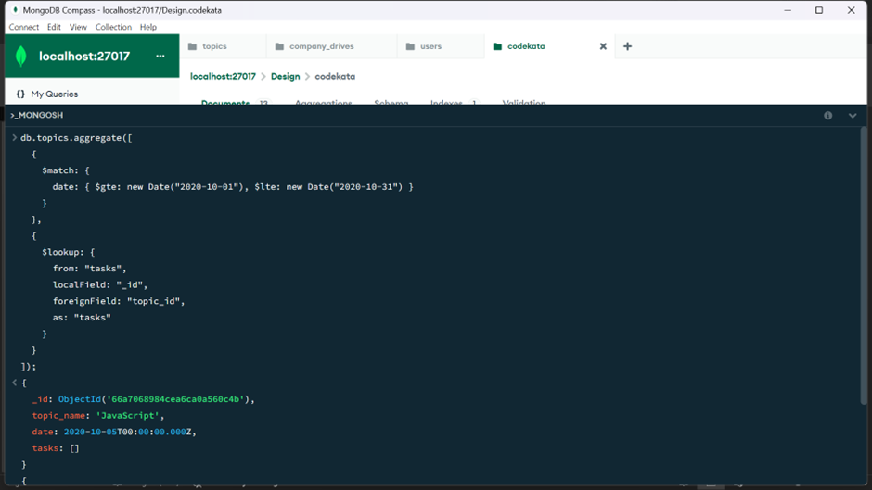

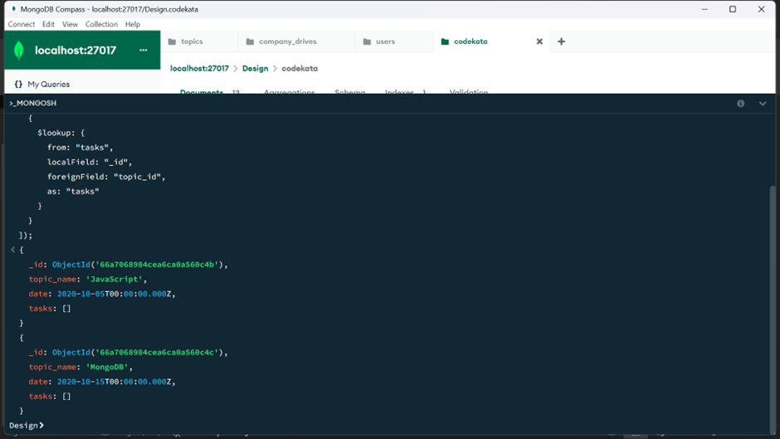

2.Find all the company drives which appeared between 15 oct-2020 and 31-oct-2020

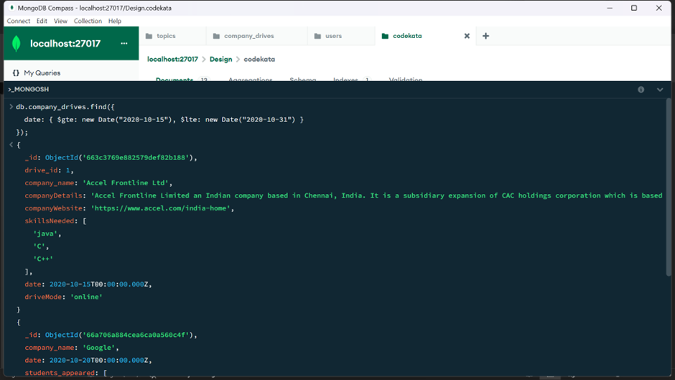

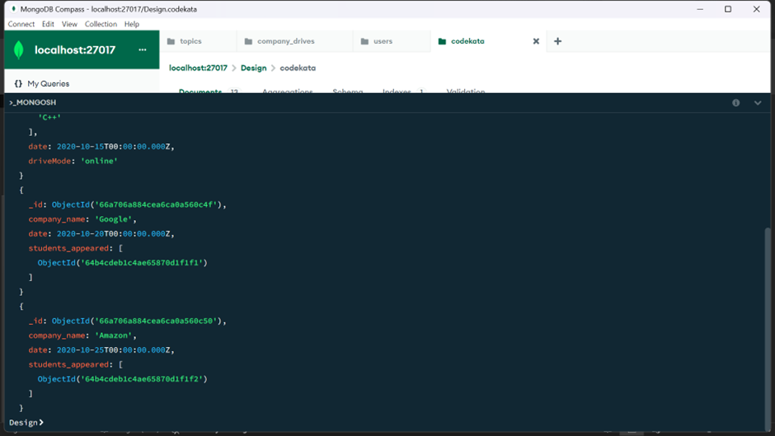

3.Find all the company drives and students who are appeared for the placement.

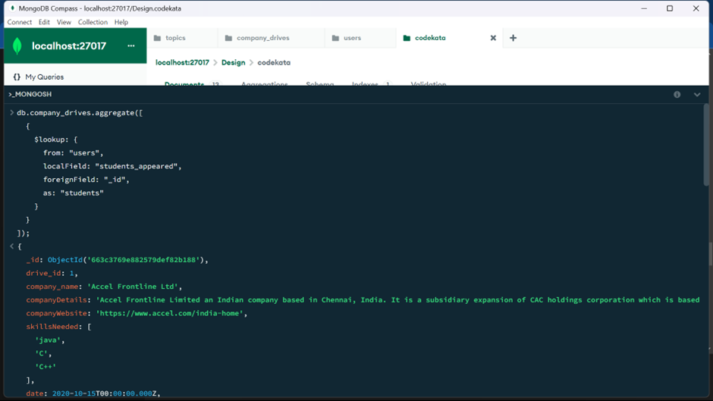

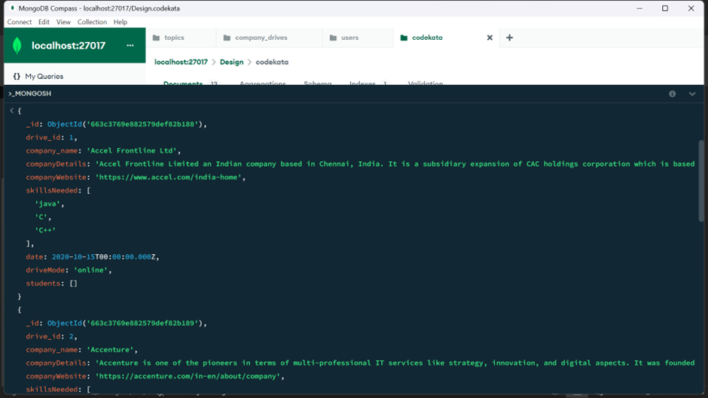

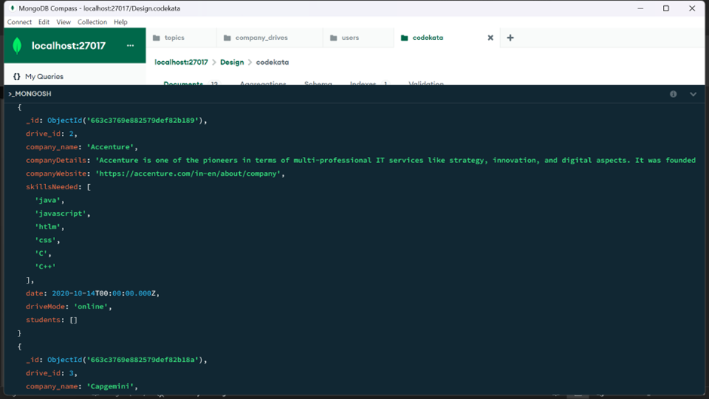

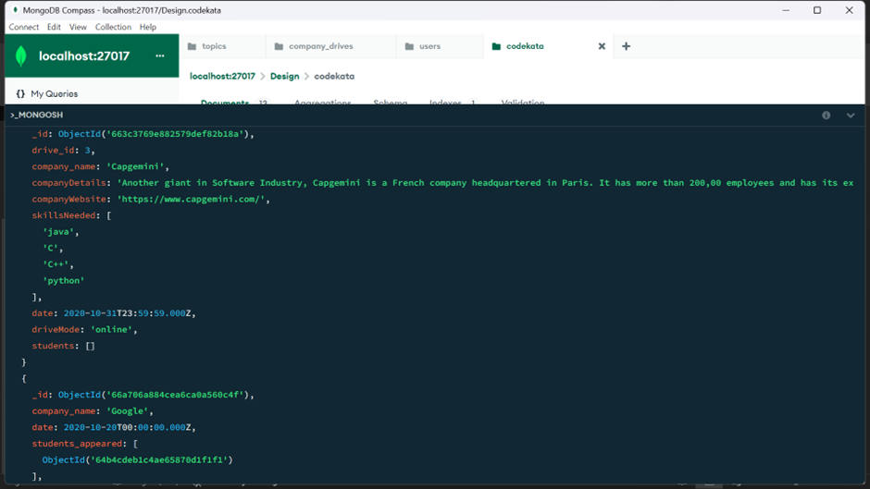

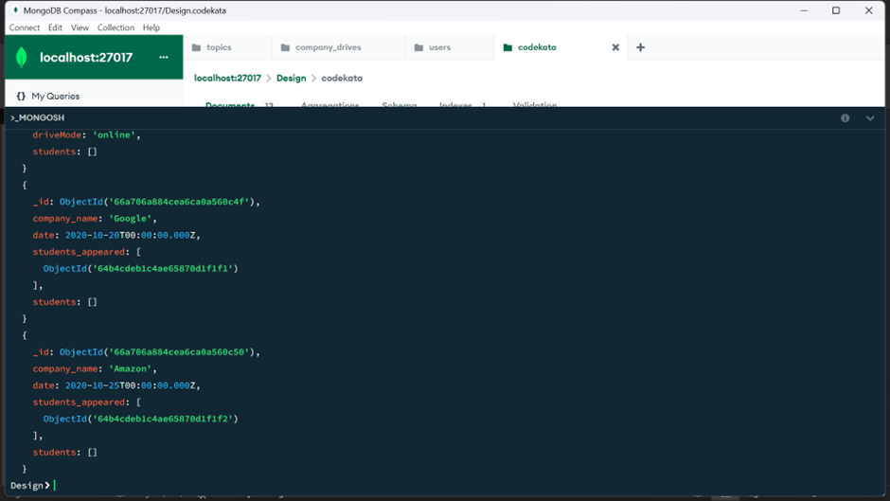

4.Find the number of problems solved by the user in codekata

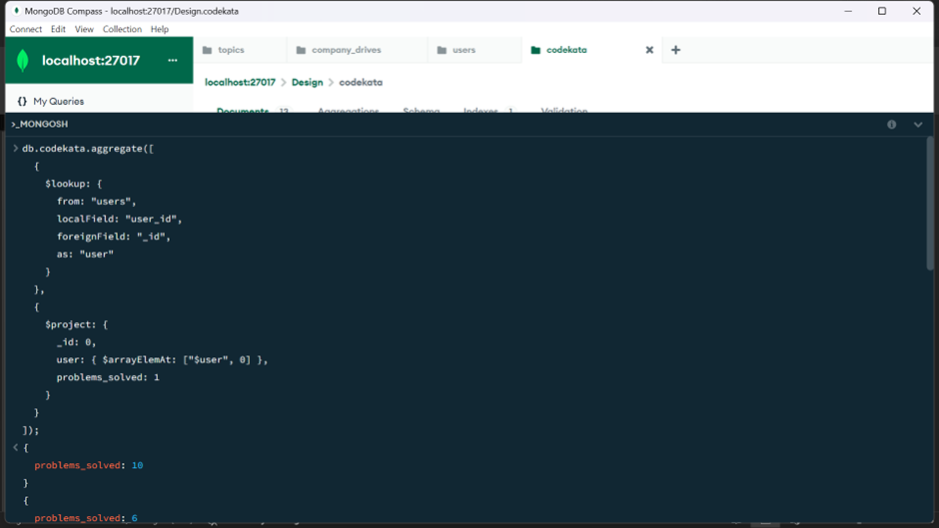

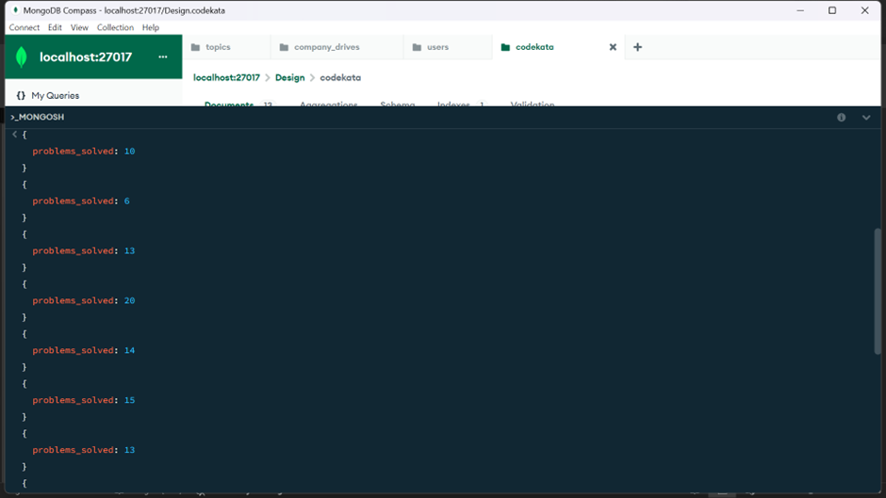

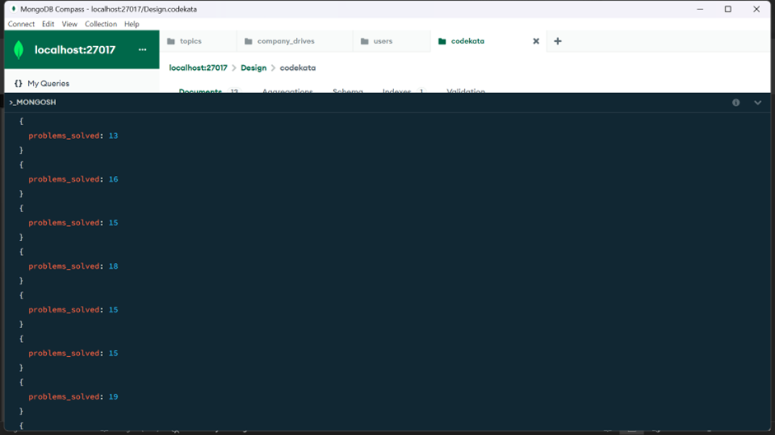

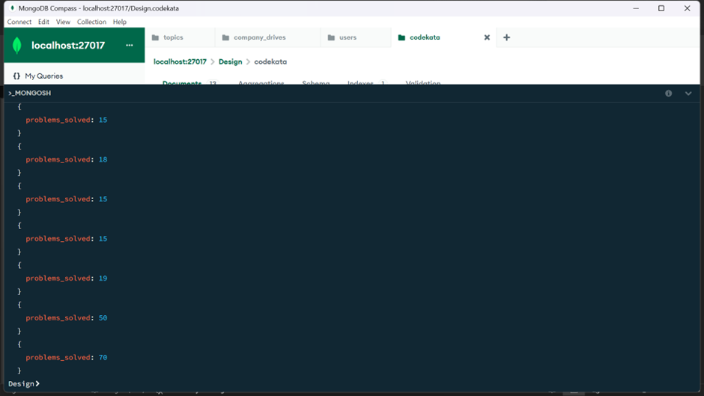

5.Find all the mentors with who has the mentee's count more than 15

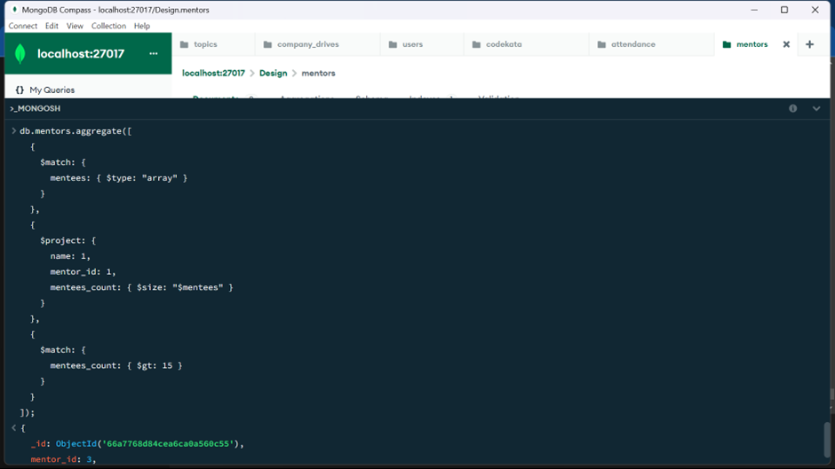

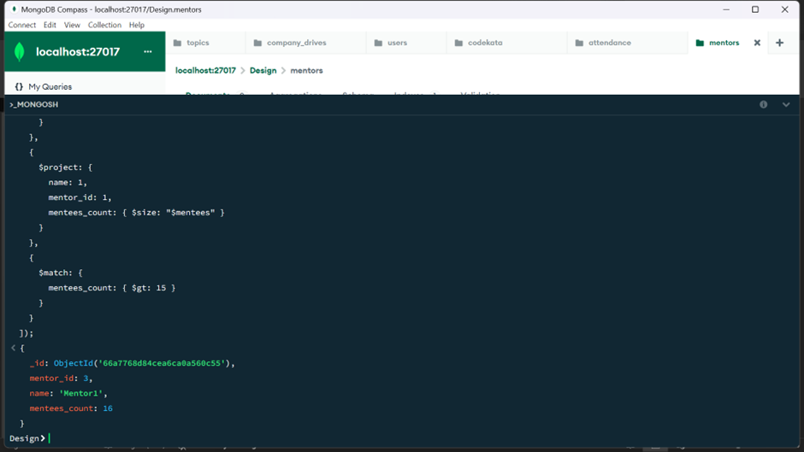

6.Find the number of users who are absent and task is not submitted  between 15 oct-2020 and 31-oct-2020

